Republic of the Philippines

**SOUTHERN LEYTE STATE UNIVERSITY**

Main Campus, Sogod, Southern Leyte

Website: [www.slsuonline.edu.ph](http://www.slsuonline.edu.ph)

Email: [slsumaincampus@gmail.com/](mailto:slsumaincampus@gmail.com/)

[op@slsuonline.edu.ph](mailto:op@slsuonline.edu.ph)

Telefax: (053) 382-3294

*Picture*

**Integrative Documentary Portfolio (IDP)**

Prepared by:

Juvie V. Cano

Submitted to:

Rene C. Radaza



Comp

College of Computer Studies and Information Technology

2021

**TABLE OF CONTENTS**

***Cover Page***

***Table of Contents***

**PART I: Preliminary**

Introduction

Program Objectives

System Organization

Learning Tasks/Performance Summary

**PART II: REFLECTION**

***Data Structures and Algorithms***

Rationale

Reflection

***Platform Technologies***

Rationale

Reflection

***Objected Oriented Programming***

Rationale

Reflection

***Fundamentals of Database System***

Rationale

Reflection

**PART I: INTRODUCTION**

This Integrative Documentary Portfolio (IDP) is a presentation of an organized documentation of my growth and achievement as a student. This provides a tangible evidence of the attainment of professional knowledge, skills, dispositions, and attributes specified in the program outcomes under the Bachelor of Science in Information Technology.

This portfolio integrates my best outputs produced during final term of all courses enrolled this semester. Reflections on my learning experience to attain the program objectives and outcomes are documented in this portfolio though images, graphs, text and others.

**PROGRAM OBJECTIVES**

The BS Information Technology (BSInfoTech) program includes the study of the utilization of both hardware and software technologies involving planning, installing, customizing, operating, managing and administering, and maintaining information technology infrastructure that provides computing solutions to address the needs of an organization.

The program prepares graduates to address various user needs involving the selection, development, application, integration and management of computing technologies within an organization.

**Program Objectives**

1. Produce manpower with competitive skills, knowledge and vibrant ideas in information and communication technology of the region.

The program shall generate potential IT workforce in the region and beyond who can apply marketable knowledge using current techniques, skills, tools and practices in the areas of information and communication technology. They shall be ready to solve complex computing problems and succeed future challenges in their working place.

|  |  |
| --- | --- |
| **Element of Program Objective** | **Behavioral indicator of the Element of Program Objective** |
| Knowledge for solving computing problems | Completed and successfully defended Capstone Project in line with the discipline |
| Problem Analysis | Documented software/hardware requirements specifications following computing industry standards. |
| Design/Development of solutions | Designed and developed a computing solution using object-oriented approach. |
| Modern tool usage | Used an integrated development environment |
| Individual and team work | Worked in a group to develop a machine project. |
| Communication | Presents a proposed solution in class or in public forum. |
| Computing Professionalism and Ethics | Immersed/exposed in an actual working environment in industry. |

1. Enhance their work attitudes, ethics, moral values, character, and personal discipline.

The students shall be instilled with the right attitude, principles and values, and shall gain strong motivation towards work. They shall be inculcated with the ability to recognize the legal, social, ethical and professional issues involved in the utilization of computer technology through adherence to applicable statutory, regulatory, industry and institutional standards and laws. Also, the students shall commit their selves to growth and be growth-oriented individuals.

|  |  |
| --- | --- |
| **Element of Program Objective** | **Behavioral indicator of the Element of Program Objective** |
| Individual and team work | Worked in a group to develop a machine project. |
| Computing Professionalism and Ethics | Immersed/exposed in an actual working environment in industry. |

1. Develop and nurture the students’ capabilities in research and extension relative to information and communication technology.

Enhance and support students’ knowledge and ideas through research and extension activities relative to information and communication technology. Research will expose them to the known and unknown parts of the field and build or innovate from it. Extension activities will also explicitly allow them to transfer their knowledge to the community giving them more opportunities to help.

|  |  |
| --- | --- |
| **Element of Program Objective** | **Behavioral indicator of the Element of Program Objective** |
| Problem Analysis | Documented software/hardware requirements specifications following computing industry standards. |
| Design/Development of solutions | Designed and developed a computing solution using object-oriented approach. |
| Modern tool usage | Used an integrated development environment |
| Individual and team work | Worked in a group to develop a machine project. |
| Communication | Presents a proposed solution in class or in public forum. |

1. Enrich their creative and critical thinking, innovation, and excellence in their fields.

This educational objective is what helps the student to think outside of the box and give them time and resources to explore new areas for innovative ideas in finding a different and better way to solve computing problems. It is a way to develop novel and unorthodox solutions on a current situation, to be curious and see beyond standard and cultural norms and to learn understanding other factors that can influence decision making in their workplace, employment and everyday living. They shall recognize opportunities for professional growth and technological updating so as to maintain the culture of excellence for the advancement of the society.

|  |  |
| --- | --- |
| **Element of Program Objective** | **Behavioral indicator of the Element of Program Objective** |
| Knowledge for solving computing problems | Completed and successfully defended Capstone Project in line with the discipline |
| Problem Analysis | Documented software/hardware requirements specifications following computing industry standards. |
| Design/Development of solutions | Designed and developed a computing solution using object-oriented approach. |
| Life-long learning | Creates a report on a conducted independent learning activity. |

**SYSTEM ORGANIZATION**

This IDP is composed of two (2) parts: Preliminary and Reflection. Part I presents the Introduction, the BSInfoTech objectives, its explanation, elements and behavioral indicators of the elements of the program objectives.

Part II contains the rationale and reflection of each course enrolled this semester. The courses are arranged starting with the major subjects, then followed with the minor subjects.

**LEARNING TASKS/PERFORMANCE SUMMARY**

|  |  |  |  |
| --- | --- | --- | --- |
| Course | Learning Tasks/Performance | Program Outcomes Addressed | Program Objectives Addressed |
| IT 201/ IT 201L | DATA STRUCTURES AND ALGORITHMS | IT01, IT02, IT03, IT04 | OBJ3, OBJ4 |
| IT 203/IT 203L | PLATFORM TECHNOLOGIES | IT01, ITO3, IT05, IT07 | OBJ1, OBJ2, OBJ3 |
| IT 205/IT 205L | OBJECT ORIENTED PROGRAMMING | IT01, IT02, IT04, IT05 | OBJ2, OBJ3 |
| IT 207/IT 207L | FUNDAMENTALS OF DATABASE SYSTEMS | IT01, IT02, ITO5, IT07, IT13 | OBJ1, OBJ3 |

**PART II. REFLECTION**

|  |  |
| --- | --- |
| **Program** | **Bachelor of Science in Information Technology** |
| Program Objective: | Develop and nurture the students’ capabilities in research and extension relative to information and communication technology.  Enrich their creative and critical thinking, innovation, and excellence in their fields. |
| Name of the artifact/ self-selected document | Module 5: Tree Data Structures |
| Date Performed: | March 2021 |
| Course/Subject: | Data Structures and Algorithms |

**Rationale**

I've chosen post-test in module 5, it is all about Tree Data Structures. The student who under this subject should draw the expression tree, create a BST and insert the following integer’s, travers the BST in order, pre-order and post order and display the data in comma separated manner, given a sequence of number and with the use of Kruskal’s algorithm to derive the minimum spanning tree and use Prim's algorithm to derive the MST starting at node. I choose this activity because trees can be used in logic and statistics. It is related to the program objective because it’s about analyzing problems and creating a solution using your own techniques to implement the link data structures such us linked list and binary trees and more.

**Reflection**

I learned a lot in this activity like I should be careful in making trees. And thinking what ways and solved the problems. And being independent of myself should apply in this task. I learned also to developed my skills, my analytical thinking and etc. so that I would be able to answer the complex problems especially in the world of IT. I need to find myself what field I’m expert or interest. The problem I’ve been meet during in doing my task. That time it was locked of signal in our place and I to climb to the mountains in order to searched and gathered some information in google or YouTube.

The elements of program outcomes achieve are apply knowledge of computing, science, and mathematics appropriate to the discipline, Understand best practices and standards and their applications. Analyze complex problems, and identify and define the computing requirements appropriate to its solution. Identify and analyze user needs and take them into account in the selection, creation, evaluation and administration of computer-based systems.

The behavioral indicators manifest during and after doing the task are documented software/hardware requirements specifications following computing industry standards. Designed and developed a computing solution using object-oriented approach. Used an integrated development environment

**Documentary**

This is my answer in post-test.

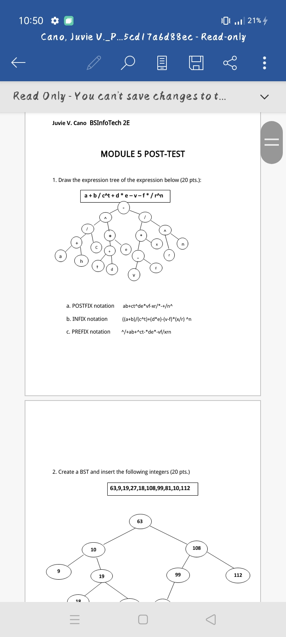

|  |  |
| --- | --- |
| **Program** | **Bachelor of Science in Information Technology** |
| Program Objective: | Produce manpower with competitive skills, knowledge and vibrant ideas in information technology and communication technology of the region.  Enhance their work attitudes, ethics, moral values, character, and personal discipline.  Develop and nurture the students’ capabilities in research and extension relative to information and communication technology. |
| Name of the artifact/ self-selected document | Module 4: Creating Simple Application |
| Date Performed: | March 2021 |
| Course/Subject: | Platform Technology |

**Rationale**

My choosing final term in module 4 post-test in designing my own calculator that has full functionality and adding more design using android studios. I choose this activity because it will enrich my creativity and critical thinking, innovation and excellence in the field. For me this activity related to the program objective because I practice myself to discipline to do the task given. And whatever difficulties I may encounter I should find a way and think what design is preferable to my application. And also, it improves the vibrant ideas of the students in creating for designing a program or an application.

**Reflection**

I learned many things in this activity like, it helps me to developed my creativity as a person, especially what design is better to apply in creating a calculator or etc. I learned also to think what’s the best, so that the user will be satisfied of my work. As a designer you should looking forward to the application you created to make the user comfortable and it could bring many advantages to your product. The problem I encountered in doing the post-test is that I don’t have a laptop and it’s hard for me to work the task. But lucky for me I have a friend that has a laptop so I borrowed from her and in doing my task I faced problems also because some topic I didn’t understand but with the helped of internet I managed to worked on it.

The elements of program outcomes achieved are apply knowledge of computing, science, and mathematics appropriate to the discipline. Analyze complex problems, and identify and define the computing requirements appropriate to its solution. Design, implement and evaluate computer-based systems, processes, components, or programs to meet desired needs and requirements under various constraints. Apply knowledge through the use of current techniques, skills, tools and practices necessary for the IT profession.

The behavioral indicators are manifested during and after doing the task are completed and successfully defended Capstone Project in line with the discipline. Documented software/hardware requirements specifications following computing industry standards. Designed and developed a computing solution using object-oriented approach. Used an integrated development environment. Worked in a group to develop a machine project.

**Documentary**

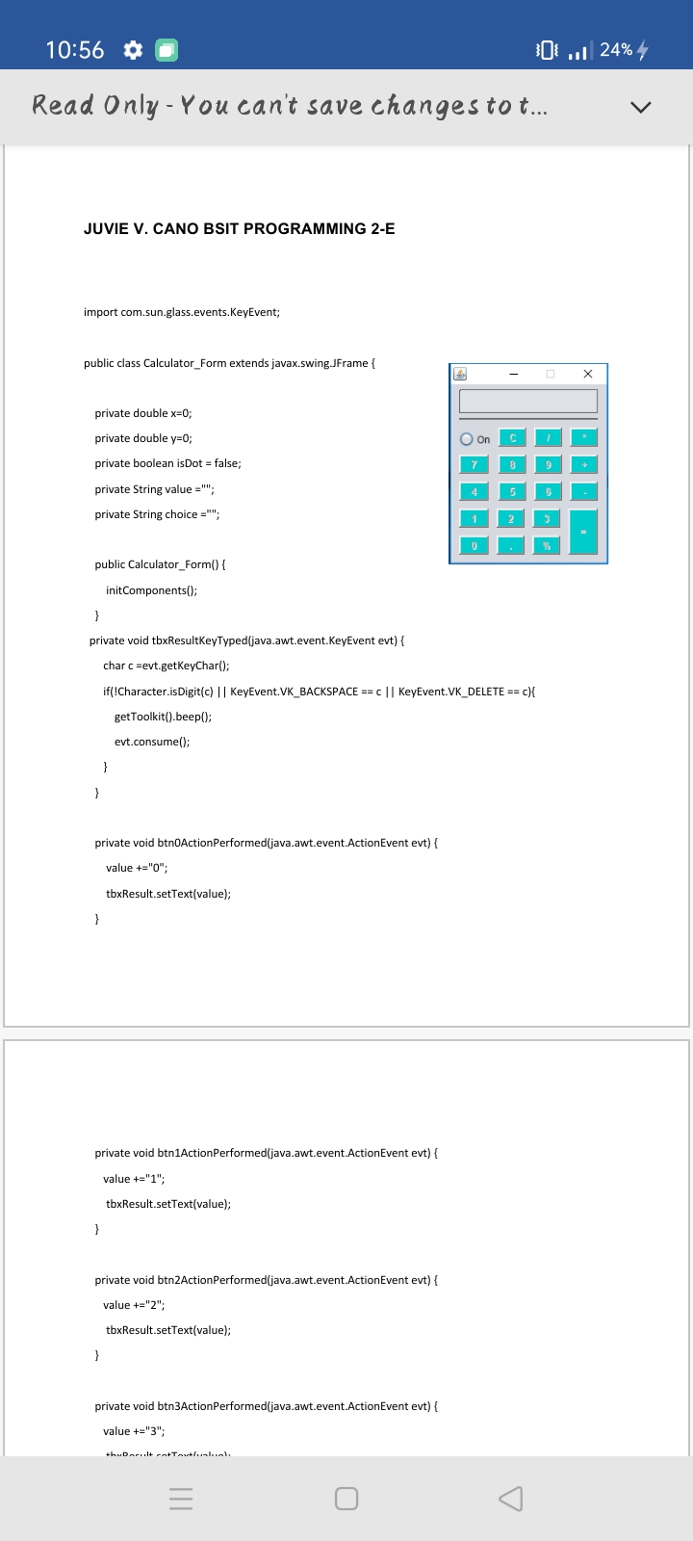**This is my worked in making my own calculator using Java Swing**

|  |  |
| --- | --- |
| Program Objective: | Enhance their work attitudes, ethics, moral values, character, and personal discipline.  Develop and nurture the students’ capabilities in research and extension relative to information and communication technology. |
| Name of the artifact/ self-selected document | Module 6: Objected Oriented Programming  Object Orientation |
| Date Performed: | March 2021 |
| Course/Subject: | Objected Oriented Programming |

**Rationale**

Post-test is me choose activity where the students solve the problem in exercises to know are understanding about the mechanism for passing object as parameter and to draw a stack diagram and show the output and to identify the codes given in the methods which are overloading/overriding and give the output in each. I choose this activity because this is the one that makes me interested and encouraged me to become a programmer. But it’s not easy, so many processes are should step up to become an expert. It is related to the program objective because it enhances the students work attitude, moral values, character, capabilities and create uncommon things.

**Reflection**

I learned to be more practical in my skills. Analyzed the topic to be inable to do and easily finished my activities. Patience should apply and never quit in the world of IT it’s not about medal it’s about character, determination, courage, skills and knowledge about IT. For me I don’t have much problem I encountered in this task because some information I didn’t understand I’ll do a researched on google. We all know that internet is our friend in times of searching to understand and to cope up.

The elements of program outcomes achieved are apply knowledge of computing, science, and mathematics appropriate to the discipline. Understand best practices and standards and their applications. Identify and analyze user needs and take them into account in the selection, creation, evaluation and administration of computer-based systems. Design, implement and evaluate computer-based systems, processes, components, or programs to meet desired needs and requirements under various constraints. Apply knowledge through the use of current techniques, skills, tools and practices necessary for the IT profession.

The behavioral indicators are manifested during and after doing the task are completed and successfully defended Capstone Project in line with the discipline. Documented software/hardware requirements specifications following computing industry standards. Designed and developed a computing solution using object-oriented approach. Used an integrated development environment.

**Documentary**

**This is my stack diagram.**

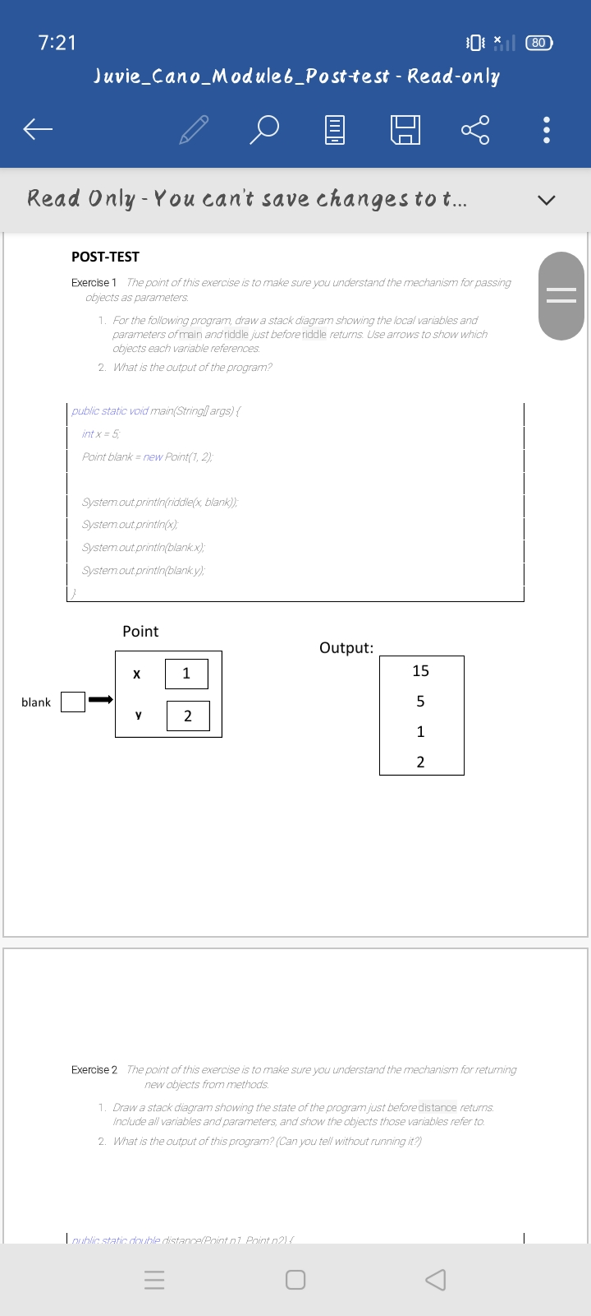

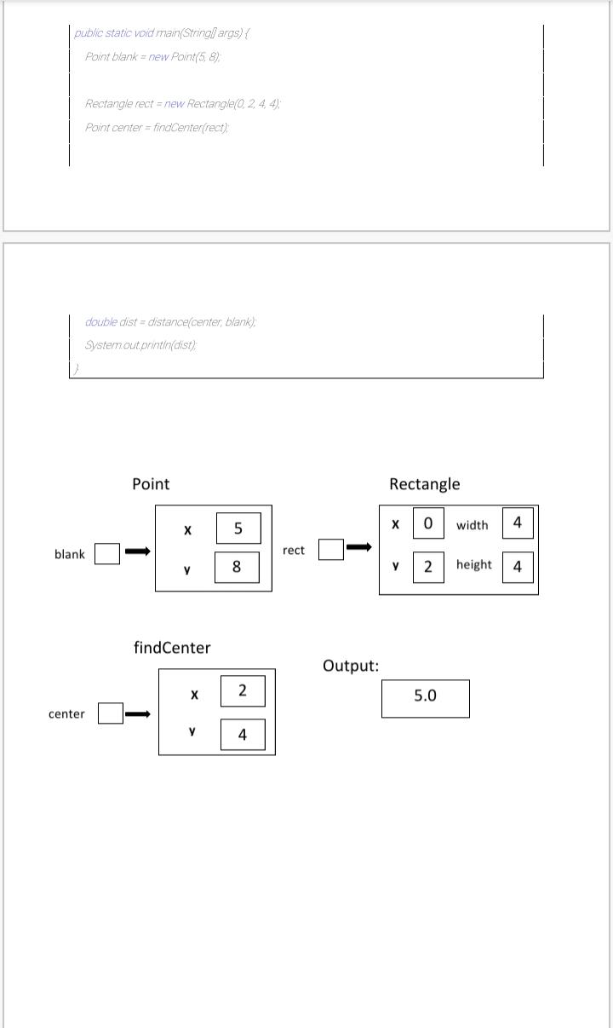

|  |  |
| --- | --- |
| Program Objective: | Enhance their work attitudes, ethics, moral values, character, and personal discipline.  Develop and nurture the students’ capabilities in research and extension relative to information and communication technology. |
| Name of the artifact/ self-selected document | Module 5: USING CONVERSION FUNCTION AND CONDITIONAL EXPRESSIONS |
| Date Performed: | March 2021 |
| Course/Subject: | Fundamentals of Database System |

**Rationale**

Post-test is my chosen activity where the students Create queries that use TO_CHAR, TO_DATE and other DATE functions and Create queries that use conditional expression such as CASE, searched CASE and DECODE. I choose this activity because I want to develop and managing efficient and effective application in database. It is related to the program objective because it is all about designing and demonstrating the ability of a student s and build using databases Oracle or SQL.

**Reflection**

I learned to develop my analytical thinking and designing skills in order to do a better application, that is effective and efficient. And also, to adapt the relational design principles to achieve the functionality of an application using DBS Oracle or SQL. The problem I encountered this activity is I don’t have any laptop at that time, I did not finish my task early it’s because I don’t have any device. All I need to do that time is to borrowed a laptop from my classmate, it’s difficult for me to rely to someone that time but this is the life of being a student sacrifice in everything in order to achieve your goals even though when you’re in the midst of stress, disappointment, loss of encouragement and etc. but you need to do something to make it finish and achieve.

The elements of program outcomes achieved are apply knowledge of computing, science, and mathematics appropriate to the discipline. Understand best practices and standards and their applications. Design, implement and evaluate computer-based systems, processes, components, or programs to meet desired needs and requirements under various constraints. Apply knowledge through the use of current techniques, skills, tools and practices necessary for the IT profession. Recognize the need for and engage in planning self-learning and improving performance as a foundation for continuing professional development.

The behavioral indicators are manifested during and after doing the task are ccompleted and successfully defended Capstone Project in line with the discipline. Documented software/hardware requirements specifications following computing industry standards. Designed and developed a computing solution using object-oriented approach. Used an integrated development environment.

**Documentary**

**This is the queries that I created.**

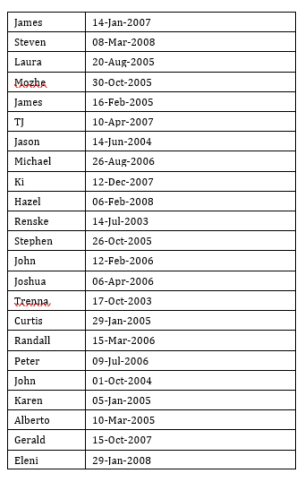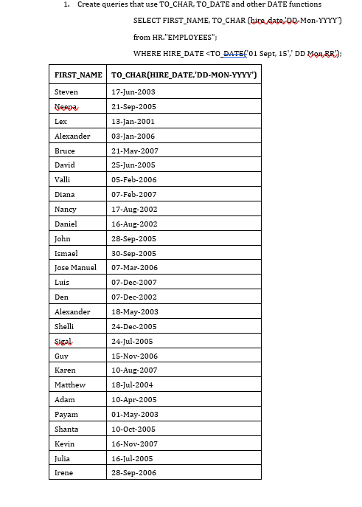

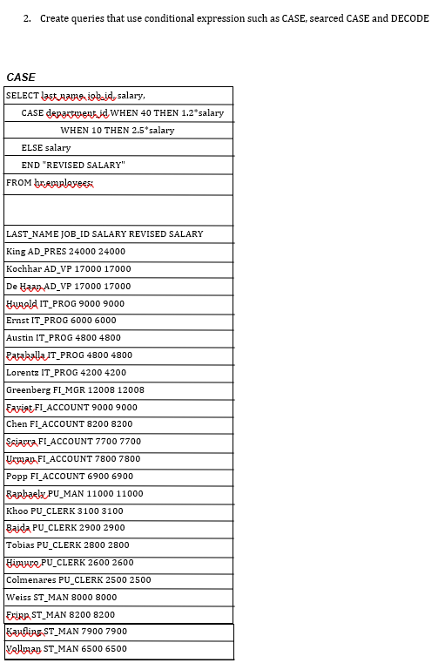

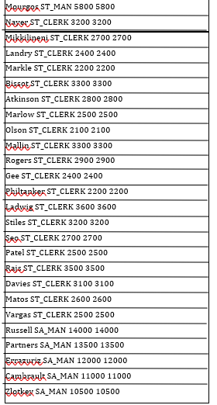

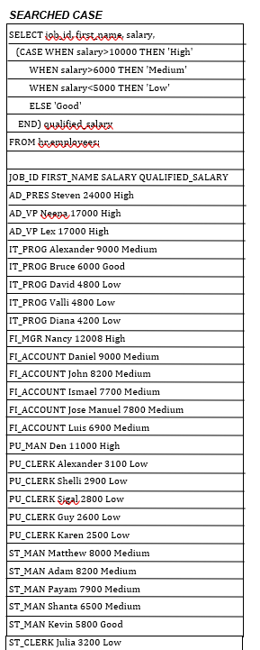

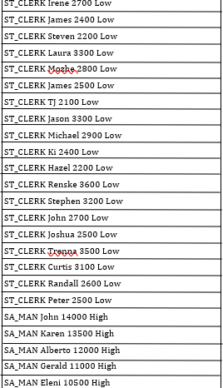

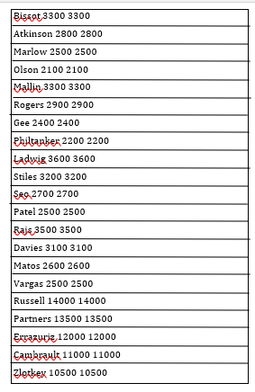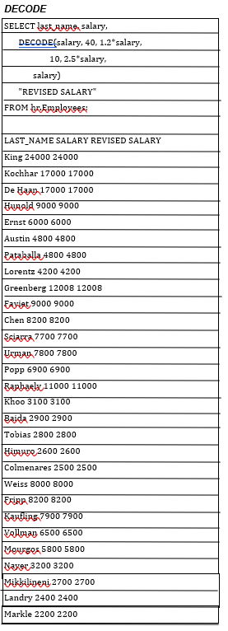

Republic of the Philippines

**SOUTHERN LEYTE STATE UNIVERSITY**

Main Campus, Sogod, Southern Leyte

Website: [www.slsuonline.edu.ph](http://www.slsuonline.edu.ph)

Email: [slsumaincampus@gmail.com/](mailto:slsumaincampus@gmail.com/)

[op@slsuonline.edu.ph](mailto:op@slsuonline.edu.ph)

Telefax: (053) 382-3294

**FINAL TERM**

**Integrative Documentary Portfolio (IDP)**

**Instructors:**

Florentino C. Gozo

Randy Siervo

Jude Ymari P. Ansale

Rene C. Radaza